NALAIYA THIRAN PROGRAM

**AI-POWERED NUTRITION ANALYZER FOR FITNESS ENTHUSIASTS**

**PROJECT REPORT**

# SUBMITTED BY

|  |  |  |
| --- | --- | --- |
| **JAVAJI SOWJANYA** | **722819104048** |  |
| **KURAM POOJASREE** | **722819104066** |  |
| **P SIVA KUMAR** | **722819104094** |  |
| **RAJAKA PAVANI** | **722819104107** |  |

### INDUSTRY MENTOR Ms. Sri Tulasi

**FACULTY MENTOR Ms. Kalaivani K**

**SRI ESHWAR COLLEGE OF ENGINEERING AN AUTONOMOUS INSTITUITION**

**COIMBATORE**

**CONTENTS**

1. **INTRODUCTION**
   1. Project Overview
   2. Purpose

### LITERATURE SURVEY

* 1. Existing problem
  2. References
  3. Problem Statement Definition

### IDEATION & PROPOSED SOLUTION

* 1. Empathy Map Canvas
  2. Ideation & Brainstorming
  3. Proposed Solution
  4. Problem Solution fit

### REQUIREMENT ANALYSIS

* 1. Functional requirement
  2. Non-Functional requirements

### PROJECT DESIGN

* 1. Data Flow Diagrams
  2. Solution & Technical Architecture
  3. User Stories

### PROJECT PLANNING & SCHEDULING

* 1. Sprint Delivery Schedule

### CODING & SOLUTIONING (Explain the features added in the project along with code)

* 1. Feature 1
  2. Feature 2
  3. Database Schema (if Applicable)

### TESTING

* 1. Test Cases
  2. User Acceptance Testing

### RESULTS

* 1. Performance Metrics

### ADVANTAGES & DISADVANTAGES

1. **CONCLUSION**
2. **FUTURE SCOPE**
3. **APPENDIX**

Source Code

GitHub & Project Demo Link

1. **INTRODUCTION**

### PROJECT OVERVIEW

A greater need for technology solutions is being created as the globe grows more health conscious. This worldwide trend has helped several businesses and websites in India that cater to this sector. These systems employ AI and its various subsets to estimate caloric intake and offer meal recommendations for a healthy diet. What we see most frequently is that these platforms act as data repositories, providing real-time data to a large number of clients that operate in this sector in exchange for a set of fees. In this article, we look at the top online platforms that use deep learning and artificial intelligence (AI) to provide real-time information on food consumption. Building a model to classify fruits according to their various characteristics, such as colour and form, is the project's main objective.

### PURPOSE

Fruit characteristics include hue, form, and texture, among others. Here, users may capture images of different fruits, which are then uploaded and analyzed by a trained algorithm. The major objective of the project is to build a model that will be used to categorise fruit according to the various nutrients. The programme examines the image and finds nutrients like glucose, fibre, and protein based on the fruits.

## LITERATURE SURVEY

### 2.1. EXISTING PROBLEM

The chance of developing some illnesses and other health problems, such as being overweight or obese, tooth decay, and high blood pressure, can rise over time as a result of inadequate nutrition. Short-term effects include an increase in stress, weariness, and our ability to perform. Today, it is well established that inadequate intakes of particular nutrients increase the chance of contracting chronic diseases such different cancers, heart disease, diabetes, osteoporosis, and depression. The health of the unborn kid might be negatively impacted long-term by inadequate vitamin intake during pregnancy.

### REFERENCES

* + - Published on April 8, 2019 From Gynaecology to Data Science : The journey of Dr Nitin Paranjape. Analyticsindiamag.com, Akshaya Asokan.
    - Côté, Mélina, and Benoît Lamarche. "Artificial intelligence in nutrition research: perspectives on current and future applications." Applied Physiology, Nutrition, and Metabolism 47, no. 1 (2022): 1-8.
    - Johnson, Kipp W., Jessica Torres Soto, Benjamin S. Glicksberg, Khader Shameer, Riccardo Miotto, Mohsin Ali, Euan Ashley, and Joel T. Dudley. "Artificial intelligence in cardiology." Journal of the American College of Cardiology 71, no. 23 (2018): 2668- 2679.
    - Hessler, Gerhard, and Karl-Heinz Baringhaus. "Artificial intelligence in drug design." Molecules 23, no. 10 (2018): 2520.
    - Heydarian, Hamid, Marc Adam, Tracy Burrows, Clare Collins, and Megan E. Rollo. "Assessing eating behaviour using upper limb mounted motion sensors: A systematic review." Nutrients 11, no. 5 (2019): 1168.
    - Demirci, Ferhat, Pinar Akan, Tuncay Kume, Ali Riza Sisman, Zubeyde Erbayraktar, and Suleyman Sevinc. "Artificial neural network approach in laboratory test reporting: learning algorithms." American Journal of Clinical Pathology 146, no. 2 (2016): 227-237.

### PROBLEM STATEMENT DEFINITION

How much exercise you need depends on your individual fitness goals and current level of fitness. It's important to start with what you can do and to pay attention to your body's

indications of discomfort and damage. A common health issue is being overweight, which is indicated by a high proportion of body fat. If you are overweight or obese, you have a higher chance of dying from conditions including hypertension, coronary heart disease, sleep apnea,

endometrial, breast, prostate, and colon cancer. Junk food induces obesity by raising metabolic weight since it has a lot of calories but little nutritious value. In addition to the major disorders like diabetes or high cholesterol, an obese individual is more prone to acquire NCDs and stroke. Overtraining might deteriorate the immune system.

## IDEATION AND PROPOSED SOLUTION

### EMPATHY MAP CANVAS

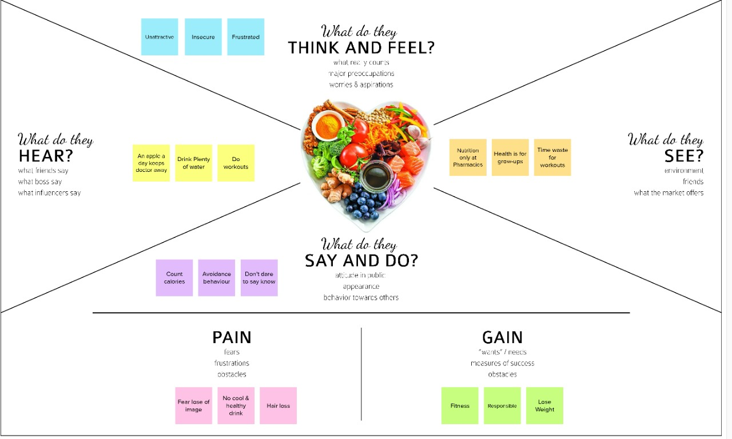

* 1. **IDEATION AND BRAINSTORMING**

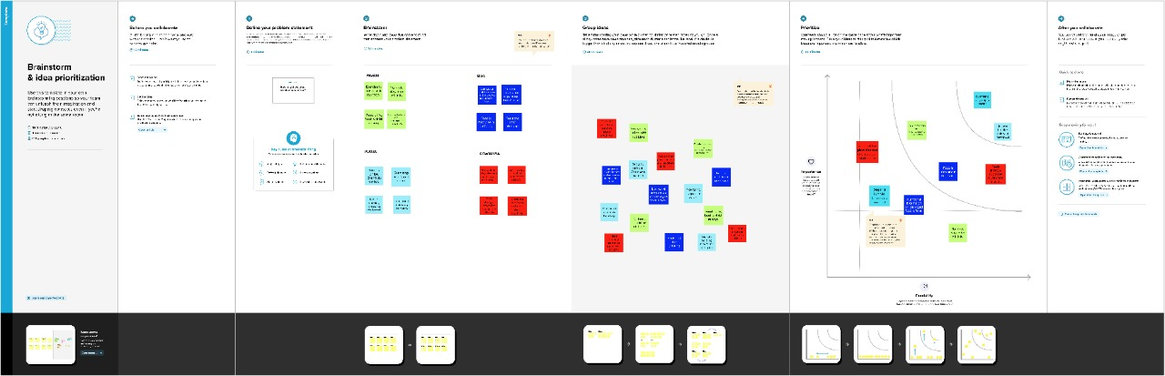

* 1. **PROPOSED SOLUTION**

**Problem Statement:** To determine the food's nutritional content and to aid in their nutrient fitness. Food is a necessity for human life and has been addressed in several medical conventions. Modern dietary evaluation and nutrition analysis technologies provide consumers additional possibilities to explore nutrition patterns, comprehend their daily eating habits, and keep up a balanced diet. Finding out a food's nutritional value is done through nutritional analysis. Information on the chemical make-up, processing, quality assurance, and contamination of food is a crucial component of analytical chemistry. Building a model that can be used to categorize fruits according to their many attributes, such as colour, shape, and texture, is the project's major goal. Here, users may take pictures of various fruits, which are subsequently uploaded to a trained algorithm for analysis. The algorithm examines the picture and determines the nutritious content of fruits such (Sugar, Fiber, Protein, Calories, etc.).

**Idea / Solution Description:** In this project, we'll count the number of calories in various foods and suggest the healthiest foods for people to eat. providing precise input data identification and dietary guidance based on data gathered in line with the user's physical conditions

**Novelty / Uniqueness:** It makes suggestions based on a person's BMI by using AI to categorize different nutrients in the fruit. Thanks to improved dietary evaluation and nutrition analysis technology, there are more chances available today to help people understand their daily eating habits, examine nutrition patterns, and maintain a balanced diet. • Analytical chemistry, which covers the process of testing the nutritional content of food, provides all three services—food contamination, composition processing, and quantity control. Simply put, we follow a diet during the day. A balanced diet also contains the recommended daily intake of each vitamin. • For best health, a lifetime of proper nutrition is required. Eating a balanced diet can lower your risk of obesity, coronary heart disease, stroke, some cancers, type 2 diabetes, high blood pressure, osteoporosis, and tooth decay.

**Social Impact / Customer Satisfaction:** People are not required to have their own personal trainers. They can easily keep up their fitness, and it is cost-effective. There is a cause-and-effect relationship between a person's nutritional state and their social, psychological, and cultural surroundings. Cultural norms, financial security, and perspectives on health and sickness all have an impact on someone's eating habits. • A healthy diet helps youngsters grow and develop normally and reduces their risk of getting chronic illnesses. Adults who eat healthily are less likely to develop obesity, heart disease, type 2 diabetes, and a number of cancers• In addition, despite the fact that unfavorable cultural norms are only one of many factors that contribute to the emergence of mental health problems and eating disorders, diet culture has an impact on the rising prevalence of anorexia, bulimia, binge eating disorder, and avoidant/restrictive food intake disorder.

**Business Model:** The goal of this application's business strategy is to help individuals lose weight through a healthy diet. consultation with local trainers and nutritionists for individualized plans. Adopt a specific diet while receiving professional advice. Promote fitness gear and dietary supplements. Advertising for health clubs and hospitals.

**Scalability:** The program has a great degree of scalability because it may be utilized by users of any age and with any form of co-morbidities. Make whole grains up to at least 50% of the grains you consume daily. Products made from whole grains are a substantial source of fiber and energy. You may prevent many chronic, non-communicable diseases including cancer, diabetes, and heart disease with a good diet. For optimal health, a balanced diet with low amounts of salt, sugar, saturated fats, and trans fats from industrial manufacture is essential.

### PROBLEM SOLUTION FIT

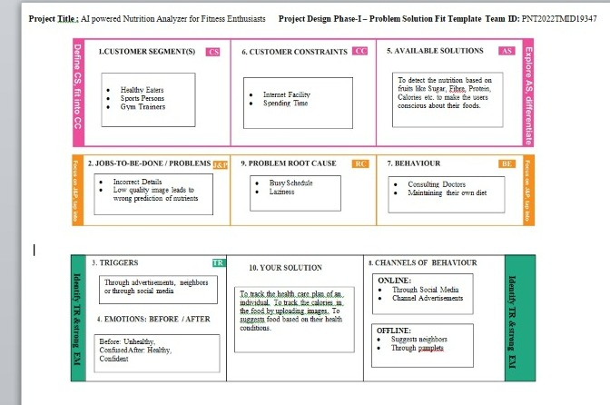

1. **REQUIREMENT ANALYSIS**
   1. **FUNCTIONAL REQUIREMENTS**
      * User Registration
      * User Confirmation
      * User Login
      * Choose package
      * Generate the daily plan
      * Query

### NON-FUNCTIONAL REQUIREMENTS

* + - Usability
    - Security
    - Efficiency
    - Portability
    - Scalability
    - Reliability

## PROJECT DESIGN

### DATA FLOW DIAGRAMS

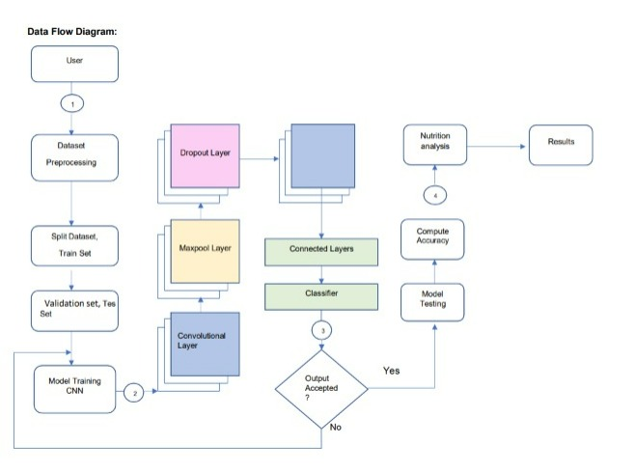

* 1. **SOLUTION AND TECHNICAL ARCHITECTURE**

In addition to suggesting a few exercise routines depending on the user's bodily circumstances, such as taking into account their BMI, etc., we are intending to develop an application that will advise the user on the quantity of nutrient content in their meals using picture processing. The user will initially enter the food item's picture. Our algorithm will analyze the image and forecast the food item's nutritional value. We will train our model using more relevant training and testing datasets to ensure that this process runs without any errors.

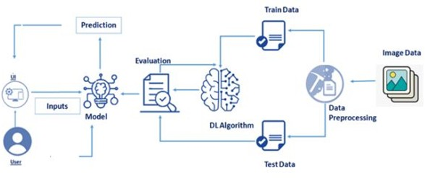

### USER STORIES

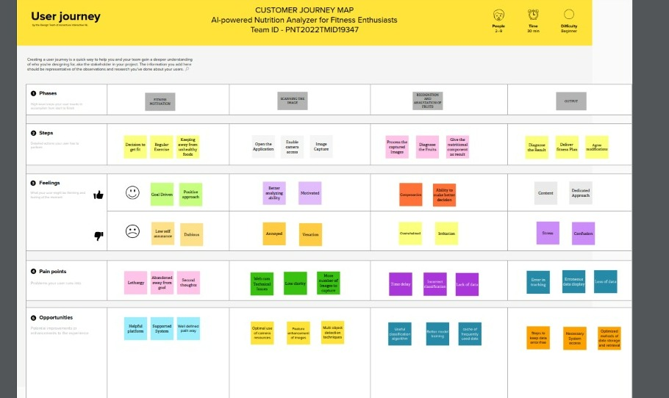

1. **SPRINT PLANNING AND SCHEDULING**
   1. **SPRINT DELIVERY SCHEDULE**

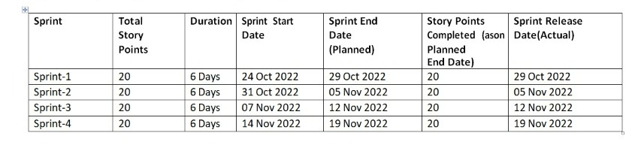

1. **CODING AND SOLUTIONING**
   1. **FEATURE 1**

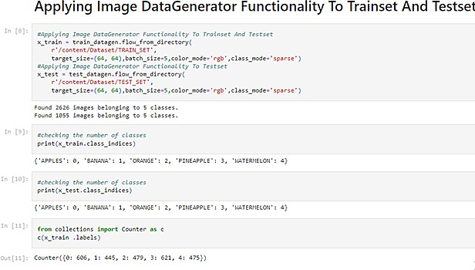

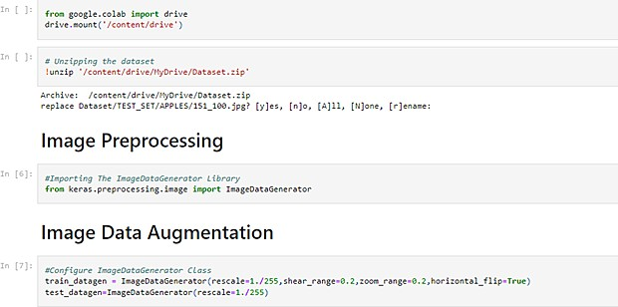

* 1. **FEATURE 2**

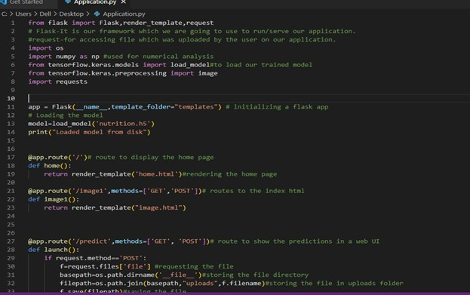

1. **TESTING**
   1. **TESTCASES**

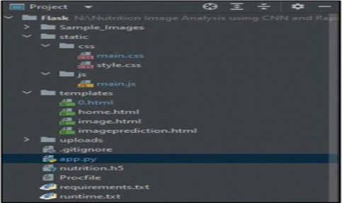

* 1. **USER ACCEPTANCE TESTING**

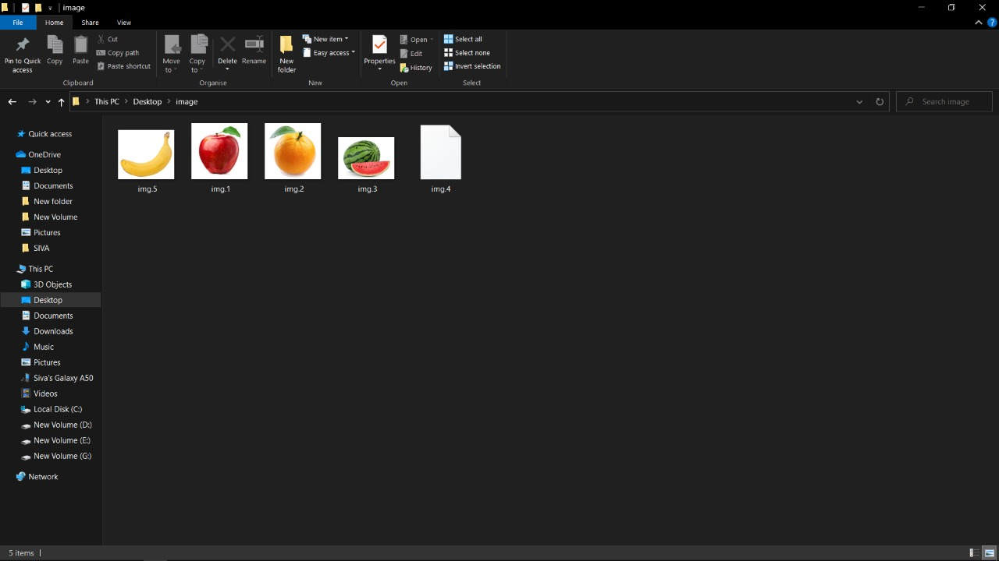

1. **RESULTS**

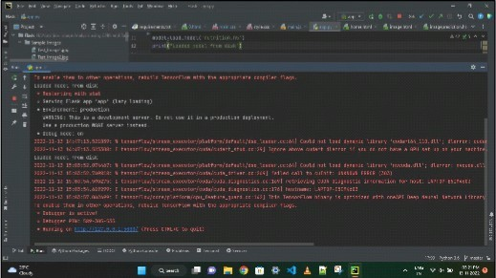

1. **ADVANTAGES**

Finding out a food's nutritional value is done through nutritional analysis. Modern dietary evaluation and nutrition analysis technologies provide consumers additional possibilities to explore nutrition patterns, comprehend their daily eating habits, and keep up a balanced diet. The ease with which our regular diet may be maintained is one of the benefits of employing this program. It aids in keeping our health in good shape. It takes the place of a physical trainer without sacrificing quality, is more affordable, and even more effective.

## CONCLUSION

Along with improved physical health and a lower risk of disease, good nutrition has been demonstrated to help academic achievement, cognitive development, and growth. This motorized nutrition analyzer is for athletes. Kids won't always select healthy foods if left to their own devices. A balanced diet and effective meal planning are necessary for a healthy body and mind. Most countries today use health education programs in schools that include student nutrition, vitamin and mineral supplements.

## FUTURE SCOPE

AI is revolutionizing the medical industry. In addition to being largely utilized to enhance marketing and sales choices, AI is currently being used to alter people's behaviors. Future versions of this program may include even more specific functions, such as the ability to analyze a person using images of their body parts or organs or to provide food recommendations based just on their appearance. With this application, image processing methods may be extremely effectively used.

## APPENDIX

### GITHUB link

https://github.com/IBM-EPBL/IBM-Project-5976-1658821519